

V 1.0
June 2025
Functional & Technical XStep Specification

EFS Bioreactor Assembly Info

Table of Contents
Functional Requirements 3
1 Purpose 3
2 Overview 3
3 Reasons for developing 3
4 Authorization 3
5 Assumptions/ Dependencies 3
6 Security Objects 4
7 Development Type 4
8 Processing Options 4
9 Functional Mapping Rules for Fields 5
10 Validation Checks 5
11 Outstanding Questions 6
12 Decisions 6
General Technical Specification 6
13 Technical XStep Layout Design 6
14 XStep Technical Specification 7
15 Function Module(s) 7
16 Technical Fields 8
17 Pseudocode 9
18 Configuration Specifications 9
19 Test Scenarios 9
20 Discussions and Emails 10
21 Document References 10
22 Revision History 10

Functional Requirements

Purpose
The document details the functional and technical design, along with the configuration specifications for the process step SiMPL: EFS Bioreactor Assembly Info. The process step allows the user to capture EFS Bioreactor parts data.

Overview
The process step allows the user to record Bioreactor Assembly information. The “Bioreactor Assembly” table captures the following part data.
- # - Output: Line number is automatically captured in the table
- Part No – Input: Capture part number in the line item of the table
- Description – Output: The part description is automatically pulled from SAP table MAKT based on the part number that was entered into the table. The field in the table is known as MAKTX.
- Batch – Input: Capture the batch of the selected part.
- Expiry – Output: Expiry information is pulled from SAP table MCH1. The field in the table is known as VFDAT. Information from this SAP table is pulled into the relevant output field of the process step.
- Autoclave Cycle No – Input: Capture the cycle number in the process step.
- Port Attached to – Input: Capture the attached port data in the process step.
- Use – Input: Capture the use data in the process step.
- Performed By – Input: Verify the data captured in the table is correct and complete.
A supervisor confirms that the data captured in the table is completed and correct by signing off in the Witnessed By field.
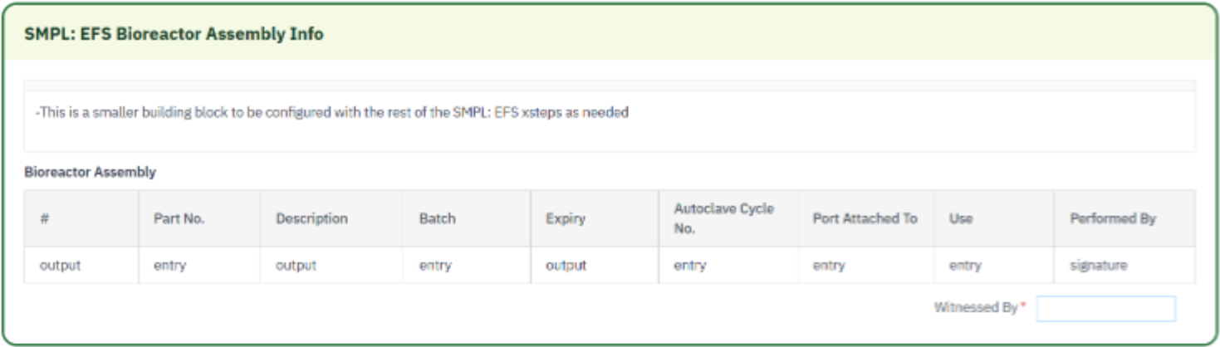

Reasons for developing
The process step EFS Bioreactor Assembly Info is developed to standardize and streamline the operations used to capture part information for Bioreactor parts. The process step pulls the associated information for the identified part into the output fields of the table. The process step contains signature fields that allows the operator and supervisor to sign off on the data that is captured in the process step.

Authorization
The user is required to have authorization to the organization’s SAP system and the organizational plant. The user is required to have a user profile setup on SAP. The profile contains a username with an associated password. The user has access to the SiMPL Fiori application.

Assumptions/ Dependencies
 | Assumption
1 | The process step contains a table that allows the user to capture sample data to the SAP system
2 | The process step contains numeric fields that allows the user to capture and record data in the system
3 | The output fields of the table are automatically populated with relevant information after the part is identified
4 | The user signing the signature fields is an approved user in the system with the correct access configuration
5 | The signature fields are set up with the correct dependencies that lock the applicable steps when executed

Security Objects
Object Name | Description
Signature validation | The user is required to provide a password validating their ID before their digital signature is accepted.
Signature Strategy | A signature strategy will be implemented so that operators or/and verifiers must sign off before goods issue transactions are locked and automatically posted in SAP.
Authorization | Appropriate authorization is required for users to execute the XStep/PI sheet.

Development Type
Development Type: |  | Report |  | Interface |  | Conversion | X | Enhancement
 |  | Form |  | Workflow |  | Portal |  | EDI
 |  | Screen |  | Data Cleansing |  | Data Dependencies
 |  | Other: | NA

Processing Options
Processing Options
Processing Mode: |  | Batch | X | Online
Frequency |  | Annually |  | Quarterly |  | Monthly |  | Weekly
 |  | Daily |  | Minutes
 |  | Other: | As required by business

Functional Mapping Rules for Fields
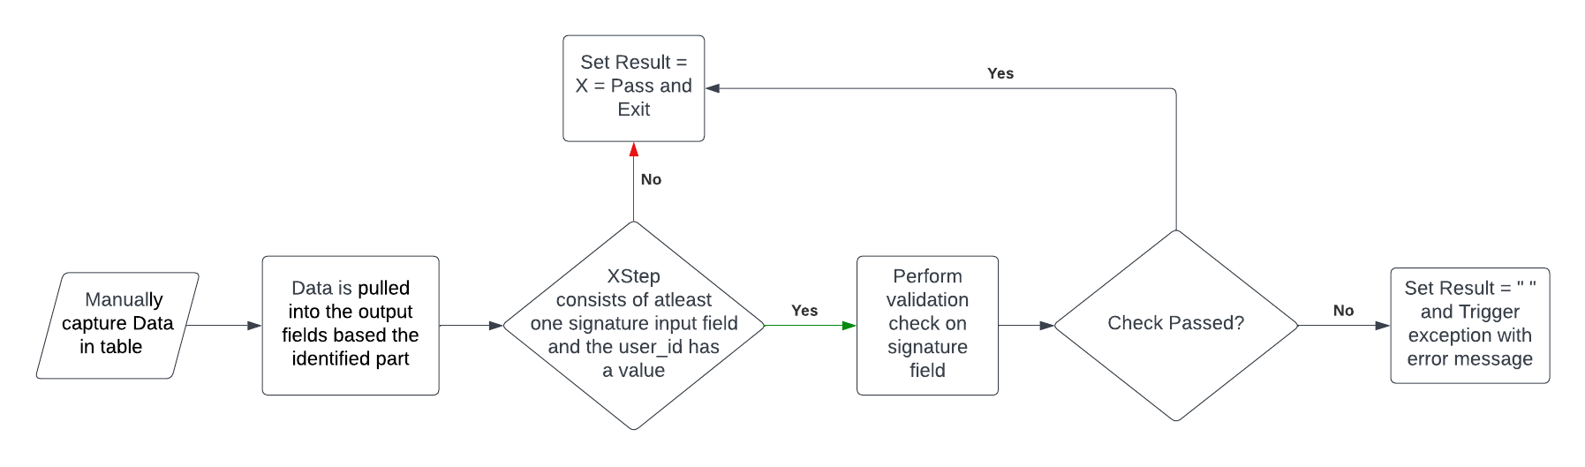

Validation Checks
Error Handling
Error | Action
The data captured in the table is incorrect | The user can update and correct the data in the table
The user signs off on the process step with the incorrect user credentials | An error message pops up and the user can update their credentials
Once the supervisor signs off in the verified field the table does not lock | Update signature rules and dependencies

Outstanding Questions
<If required list additional questions that needs further clarification>

Decisions
<If required list any client specific decisions that was made in regards to the process step/ product>
Decision Description | Date | Decision Makers
N/A | N/A
N/A | N/A

General Technical Specification

Technical XStep Layout Design
Example:
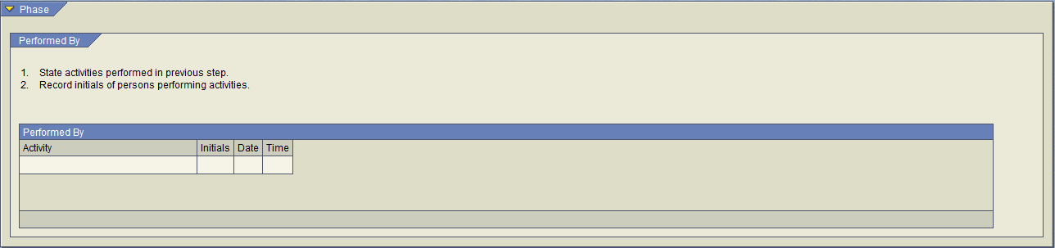
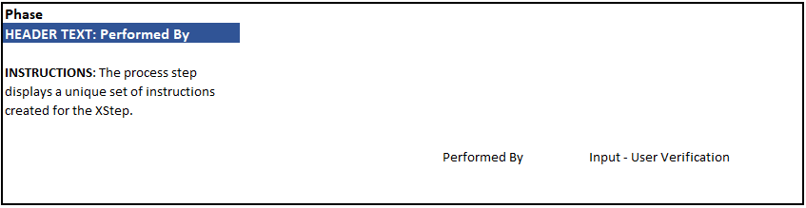

XStep Technical Specification
Parameters:
Input Parameter Name(s) | Characteristic Used
IV_HEADER | PPPI_SHORT_TEXT
IV_INSTR | PPPI_MESSAGE_TEXT

Local Parameter Name(s) | Characteristic Used
LAC_CRID | PPPI_CONTROL_RECIPE
LAV_BATCH | PPPI_BATCH
<Provide a brief technical description of how the process step or product is developed and designed>
The XStep contains the input parameter IV_INSTR that displays a fixed set of instructions. The instructions need to be followed to execute the process step correctly.
The following parameters are automatic valuation symbols:
- LAC_CRID – Control Recipe Number
- LAV_BATCH – Batch
The valuation symbols will automatically populate the user fields mentioned above with the correct and relevant data.
The process step makes use of the function module ZSMPL_FM_RD_COMP to compare the actual value that the user recorded to the critical low, low, optimal, high and critical high values that are pre-recorded in the system.

Function Module(s)
Import Parameters:
Parameter Name | Associated Type | Short Text

Export Parameters:
Parameter Name | Associated Type | Short Text

Exceptions:
Exception | Short Text

Validation Logic - Scenario 1
<Describe a Validation Scenario to test that the function module is in working order>

Technical Fields
Description | Fields | Data type | Length | Comments
Purchase Order
Material Document
Plant
Delivery Note
GR Date
Create By

The fields for the item levels are listed in the following table:
Description | Fields | Data type | Length | Comments
Item
Material
Supplier Material No.
Material Description
Stor. Location
Storage Bin
GR Qty
UoM
Long Text
Summary of GR item quantity.

Pseudocode
<Provide Pseudocode for the function module source code if required>

Configuration Specifications
<Add configuration steps/ objects in the section>

Test Scenarios
Disclaimer: The test scenarios outlined below are primarily authored by developers and architects to validate technical specifications. Each scenario is to be assigned a test ID by a Business Analyst, ensuring consistency and ease of tractability throughout the project.

# | Scenario | Type | Expected Result | Actual Result | Pass/ Fail
ID
1
2
3

Discussions and Emails
<Detail any discussions or emails surrounding the product. Provide screenshots if applicable>

Document References
Reference No. | Document Title
Number used in superscript for reference | Full name of referenced document
1 | SiMPL Functional Guide: Universal Concepts

Revision History
Version No. | Description | Author | Date
SiMPL version | Description of revisions made. Never “Improved language” or anything indicating the previous version was bad/ wrong. Only show versions previously delivered to the client. | First and Last name of Author who made revision | Date the revision was made.  MM-DD-YYYY
4.2 | Initial Document | Braxton Reimer | 07-23-2024
4.3 | Updated Functional and Technical Documents | Chane Ebersohn | 06-08-2024

